How to enroll Clements orchestra booster club in the Kroger Community Rewards Program
Step 1 Go to https://www.kroger.com/account/communityrewards/. You will be directed to a sign in page.
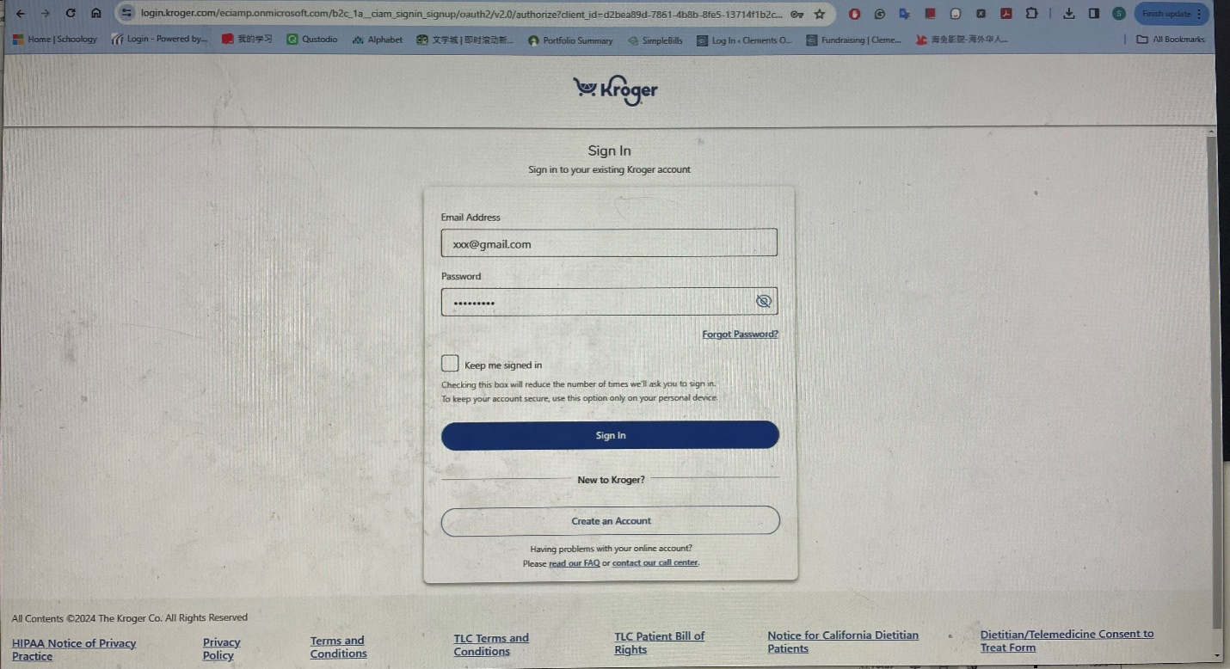
If you don’t have an account, click “Create an Account” button and follow the instructions to create a Kroger account.
If you already have an account, sign in with your credentials.

Step 2 You will see the Community Rewards page. Click Change Organization link.
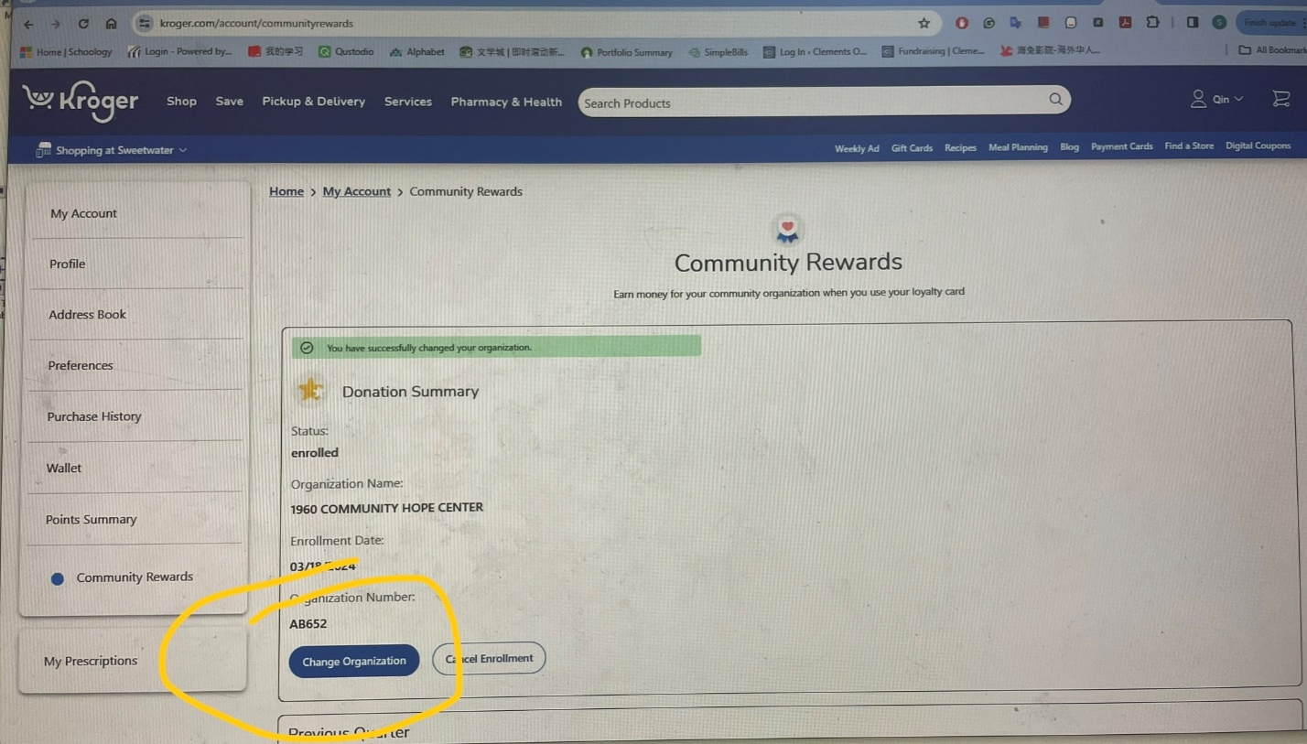

Step 3 Search for “Clements Orchestra”.
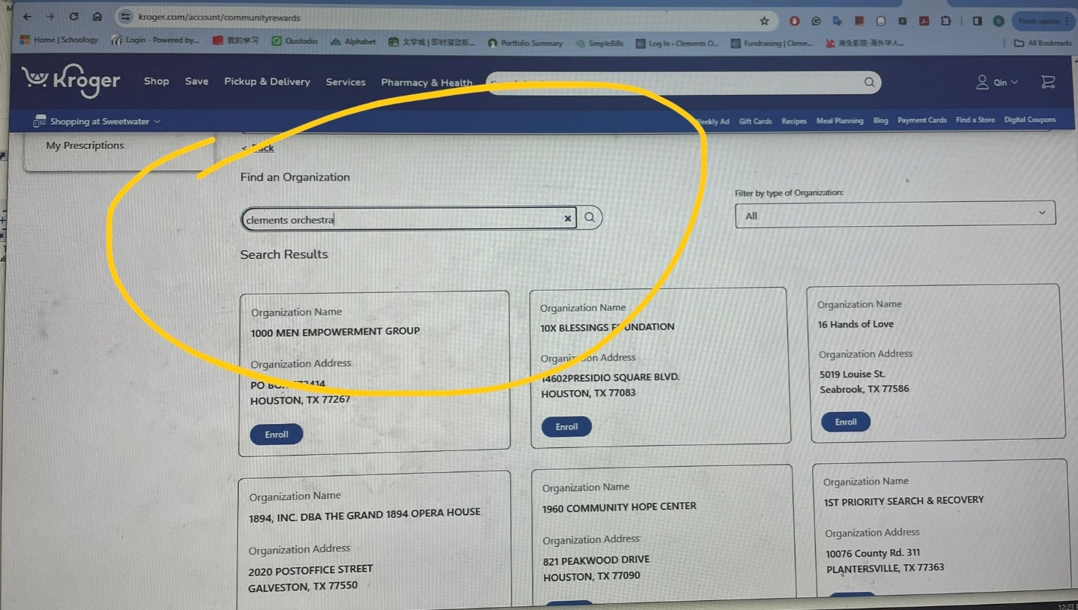

Step 4 Click Enroll button under the CLEMENTS HS ORCHESTRA BOOSTER CLUB
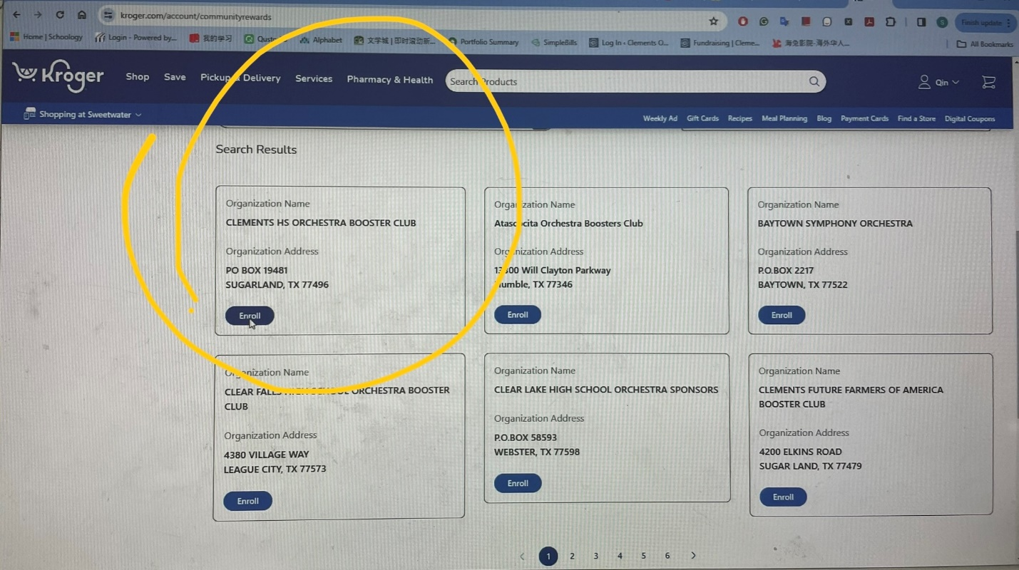

Step 5 You will see CLEMENTS HS ORCESTRA BOOSTER CLUB is enrolled in Community Rewards
